Nama : Nindy Wlandari

Nim : 1206087051

Perbaikan Nilai UAS Struktur

1. 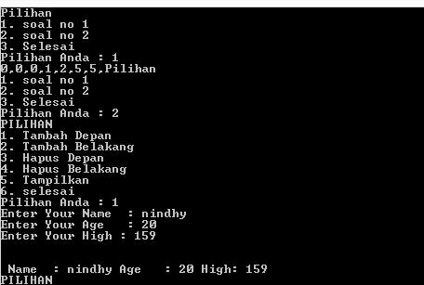Hasil Eksekusi

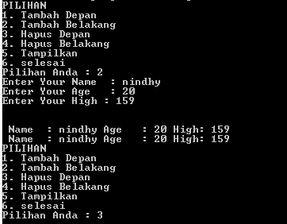

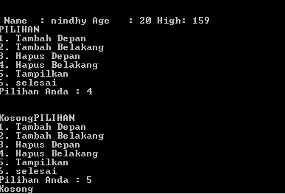

#include <iostream>

#include <conio.h>

#include <stdio.h>

using namespace std;

int pil ;

void buat_baru();

void tambah_belakang();

void tambah_depan();

void hapus_belakang();

void hapus_depan();

void tampil();

struct node

{

char name [20];

int age;

float high;

node *prev, *next;

};

node *baru, *head=NULL, *tail=NULL,*hapus,*bantu;

void print(int *a, int n)

{

int i=0;

while(i<n){

cout<<a[i]<<",";

i++;

}

}

void swap(int i,int j, int *a){

int temp = a[i];

a[i] = a[j];

a[j] = temp;

}

void quicksort(int *arr, int left, int right){

int min = (left+right)/2;

int i = left;

int j = right;

int pivot = arr[min];

while(left<j || i<right)

{

while(arr[i]<pivot)

i++;

while(arr[j]>pivot)

j--;

if(i<=j){

swap(i,j,arr);

i++;

j--;

}

else{

if(left<j)

quicksort(arr, left, j);

if(i<right)

quicksort(arr,i,right);

return;

}

}

}

void no1(){

int arr[7] = {0, 2, 1 ,0, 5, 5};

quicksort(arr,0, (sizeof(arr)/sizeof(arr[0]))-1);

print(arr, (sizeof(arr)/sizeof(arr[0])));

}

void pilih2()

{

if(pil==1)

tambah_depan();

else if(pil==2)

tambah_belakang();

else if(pil==3)

hapus_depan();

else if(pil==4)

hapus_belakang();

else if(pil==5)

tampil();

else

cout<<"selesai";

}

void no2()

{

do

{

cout<<"PILIHAN "<<endl;

cout<<"1. Tambah Depan"<<endl;

cout<<"2. Tambah Belakang"<<endl;

cout<<"3. Hapus Depan"<<endl;

cout<<"4. Hapus Belakang"<<endl;

cout<<"5. Tampilkan"<<endl;

cout<<"6. selesai"<<endl;

cout<<"Pilihan Anda : ";

cin>>pil;

pilih2();

}

while(pil!=6);

}

void pilih()

{

if(pil==1)

no1();

else if(pil==2)

no2();

else

cout<<"selesai";

}

void buat_baru()

{

baru = new(node);

cout<<"Enter Your Name : ";cin>>baru->name;

cout<<"Enter Your Age : ";cin>>baru->age;

cout<<"Enter Your High : ";cin>>baru->high;

baru->prev=NULL;

baru->next=NULL;

}

void tambah_belakang()

{

buat_baru();

if(head==NULL)

{

head=baru;

tail=baru;

}

else

{

tail->next=baru;

baru->prev=tail;

tail=baru;

}

cout<<endl<<endl;

tampil();

}

void tambah_depan()

{

buat_baru();

if(head==NULL)

{

head=baru;

tail=baru;

}

else

{

baru->next=head;

head->prev=baru;

head=baru;

}

cout<<endl<<endl;

tampil();

}

void hapus_depan()

{

if (head==NULL)

cout<<"Kosong";

else if (head->next==NULL)

{

hapus=head;

head=NULL;

tail=NULL;

delete hapus;

}

else

{

hapus=head;

head=hapus->next;

head->prev=NULL;

delete hapus;

}

cout<<endl<<endl;

tampil();

}

void hapus_belakang()

{

if (head==NULL)

cout<<"Kosong";

else if (head->next==NULL)

{

hapus=head;

head=NULL;

tail=NULL;

delete hapus;

}

else

{

hapus=tail;

tail=hapus->prev;

tail->next=NULL;

delete hapus;

}

cout<<endl<<endl;

tampil();

}

void tampil()

{

if (head==NULL)

cout<<"Kosong";

else

{

bantu=head;

while(bantu!=NULL)

{

cout<<" Name : "<<bantu->name;

cout<<" Age : "<<bantu->age;

cout<<" High: "<<bantu->high<<endl;

bantu=bantu->next;

}

}

getch();

}

int main()

{

do

{

cout<<"Pilihan"<<endl;

cout<<"1. soal no 1"<<endl;

cout<<"2. soal no 2"<<endl;

cout<<"3. Selesai"<<endl;

cout<<"Pilihan Anda : ";

cin>>pil;

pilih();

}

while(pil!=6);

}